Registering Your Gaming Device in the Dorm Wired Network
Registering your non-802.1x compliant device for wired network access
- On a separate computer or mobile device open a browser and go to https://apps.dsu.edu/dorm-mac-registration/ .
- An authentication screen will appear. Enter your DSU credentials and Click OK.
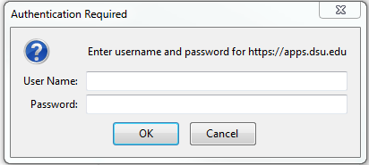
- This will bring you to your Device Registration screen. This screen will show all devices you have registered in the past. You can add or delete devices as you need. (Note: DSU will periodically clear these devices to make room in active directory especially between semesters. Please check this page first if your device loses connection.)
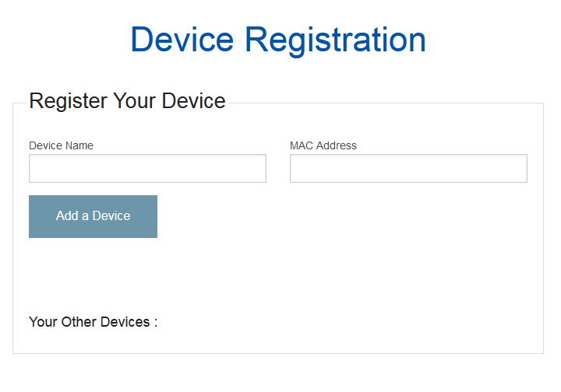

- Enter a Device Name (this can be anything to help you keep track of your devices) and the devices’ MAC address (This can generally be found in the network settings of your device. If you are having issues finding the MAC address please use Google to help you locate it.) and press Add a Device
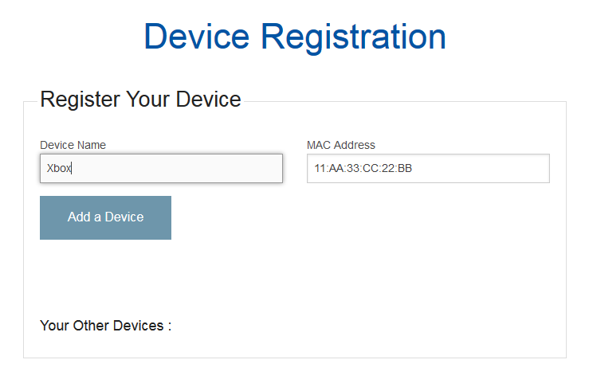
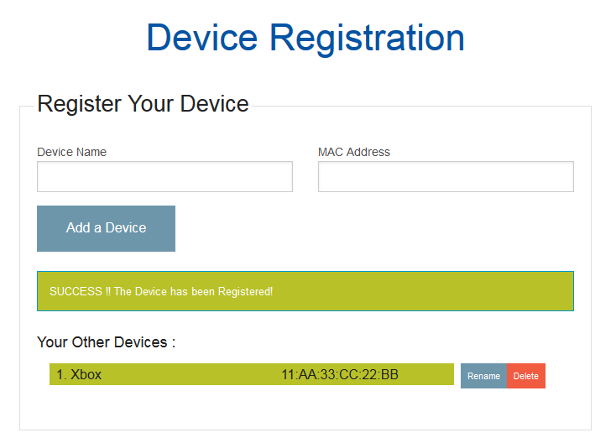
- Once you have received the successful message you can then attach your device to the ports located on the bottom of your dorm room access point labeled ENET1-4. Do not plug anything into the Pass Through port.
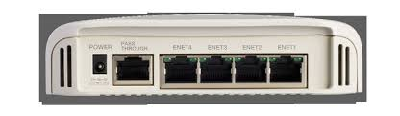

Troubleshooting Steps
- My device doesn’t have internet access but it gets a 138.247.185.xxx IP address.
  - Double check the MAC address is entered correctly in Device Registration Page.
  - Restart the device and check IP again.
  - Email help@dsu.edu

